Functional Specification Document
  - OMEGA – Open Market Execution Gateway
  - Issuance Calendar
  - v0.04

Document Control
Revision History
Revision # | Release Date | Summary of Changes | Author
0.01 | 03 Nov 2025 | Initial draft. | Eugene Cheong
0.02 | 07 Nov 2025 | Updated wireframe, email templates and cleanup based on comments. | Eugene Cheong
0.03 | 17 Nov 2025 | Updates based on user comments and feedback. | Eugene Cheong
0.04 | 23 Dec 2025 | Moved the Actors section to section 2.2.  Updated the workflow diagrams and state transition diagram.  Updated screen elements to include a more detailed description, and amended the validations for date fields. Also amended the possible values of the Year, and Security types field.  Added additional handling for empty date fields, and provisional ISIN code for syndication.  Added more details for the Change Summary and Submission History.  Updated the generation logic for MAS Bills based on the concept of a primary issue date. | Eugene Cheong

Reviewer Name (Designation) | Reviewed Version # | Date

Approver Name (Designation) | Approved Version # | Date

Table of Contents
1 Introduction 7
1.1 Purpose of Document 7
1.2 Scope 7
1.3 Definitions, Acronyms and Abbreviations 7
1.4 Reference 7
2 Functional Requirements 8
2.1 Purpose of Module 8
2.2 Actors 8
2.3 Process Diagrams 8
2.4 BPMN Workflow 10
2.5 State Transition Diagram 10
2.6 Use Cases 11
2.7 View Issuance Calendar 12
2.7.1 Description 12
2.7.2 Preconditions 12
2.7.3 Business Requirements 12
2.7.4 Post Conditions 12
2.7.5 Issuance Calendar Listing page 12
2.7.6 Issuance Calendar Details page 15
2.8 Create Issuance Calendar 27
2.8.1 Description 27
2.8.2 Preconditions 27
2.8.3 Business Requirements 27
2.8.4 Post Conditions 28
2.8.5 Create Issuance Calendar Modal 28
2.8.6 Issuance Calendar Details page 30
2.8.7 Re-upload Calendar Modal 31
2.8.8 Confirmation Prompt 32
2.9 Update Issuance Calendar 33
2.9.1 Description 33
2.9.2 Preconditions 33
2.9.3 Business Requirements 33
2.9.4 Post Conditions 33
2.9.5 Issuance Calendar Details page 34
2.9.6 Re-upload Calendar Modal 34
2.9.7 Confirmation Prompt 34
2.10 Withdraw Issuance Calendar Approval 34
2.10.1 Description 34
2.10.2 Preconditions 34
2.10.3 Business Requirements 34
2.10.4 Post Conditions 35
2.10.5 Issuance Calendar Details page 35
2.10.6 Confirmation Prompt 35
2.11 Save Issuance Calendar as Draft 36
2.11.1 Description 36
2.11.2 Preconditions 36
2.11.3 Business Requirements 36
2.11.4 Post Conditions 36
2.11.5 Issuance Calendar Details page 36
2.11.6 Confirmation Prompt 37
2.12 Delete Draft Issuance Calendar 37
2.12.1 Description 37
2.12.2 Preconditions 37
2.12.3 Business Requirements 37
2.12.4 Post Conditions 38
2.12.5 Issuance Calendar Details page 38
2.12.6 Confirmation Prompt 38
2.13 Approve/Reject Issuance Calendar 39
2.13.1 Description 39
2.13.2 Preconditions 39
2.13.3 Business Requirements 39
2.13.4 Post Conditions 39
2.13.5 Issuance Calendar Details page 39
2.13.6 Confirmation Prompt 40
2.14 Export Issuance Calendar 41
2.14.1 Description 41
2.14.2 Preconditions 41
2.14.3 Business Requirements 41
2.14.4 Post Conditions 42
2.14.5 Issuance Calendar Details page 42
2.14.6 Sample Files 42
2.15 Download Issuance Calendar Templates 42
2.15.1 Description 42
2.15.2 Preconditions 42
2.15.3 Business Requirements 42
2.15.4 Post Conditions 43
2.15.5 Issuance Calendar Listing page 43
2.15.6 Template Files 43
3 Logic for Creation of Issuance Calendars via Algorithm 44
3.1 T-Bills 44
3.2 SSBs 45
3.3 MAS Bills 46

Introduction

Purpose of Document
This Functional Specification Document is used to clearly define the intended functionality of OMEGA.
OMEGA is a platform that supports MAS’ central banking functions related to market operations and benchmark administration. OMEGA aims to improve business efficiency by leveraging on technology and design thinking, minimising manual intervention, re-engineering business processes and improving system resiliency.
OMEGA consists of several modules. This document outlines the functionality of the Issuance Calendar module, focusing on features, functions, and behaviour, without detailing how these functionalities will be technically implemented. It aims to:
- Establish a shared understanding of the system's functional scope;
- Provide a clear and unambiguous description of each functional requirement;
- Ensure that the developed system meets the identified business needs and user expectations;
- Facilitate effective communication and collaboration among all project stakeholders;
- Serve as a baseline for system development, testing, and implementation; and
- Manage and control changes to the system's functionality through a defined change management process.

Scope
The Issuance Calendar module allows MAS internal users to perform the following functionalities:
- Create or update the issuance calendars via manual entry or file upload;
- Create the issuance calendars via an algorithm (if applicable for the security type selected);
- Save the issuance calendar as draft;
- Submit the issuance calendar for approval or withdraw submissions;
- Approve the issuance calendar as part of the maker-checker process; and
- Download the issuance calendar details or the templates.

Definitions, Acronyms and Abbreviations
Acronym | Description
BPMN | Business Process Model and Notation
CDP | Central Depository Pte Limited
FI | Financial Institution
ISIN | International Securities Identification Number
MAS | Monetary Authority of Singapore
OMEGA | Open Market Execution Gateway
PD | Primary Dealer
SFTP | Secure File Transfer Protocol
SGX | Singapore Exchange
Table 1: Acronyms used in document

Reference
The following documents are referenced throughout this functional specification and should be consulted for additional context, detailed requirements, and technical information that supports the functional requirements described in this document.
- Logic for Issue Code.pdf
- MAS_OMEGA – Interface Specifications Document (MAS Website).docx
- MAS_OMEGA – Interface Specifications Document (FIs and CDP).docx
- MAS_OMEGA – Functional Specifications Document (Common Functions).docx
- MAS_OMEGA – Additional Information (Error Messages).xlsx – This file contains a list of validations in each module and their corresponding error messages.
- MAS_OMEGA – Additional Information (System Notifications and Emails).xlsx – This file contains a list of system notifications and emails in each module and their corresponding content.

Functional Requirements

Purpose of Module
MAS internal users can manage issuance calendars and its publication to the MAS website.
OMEGA contains outbound interfaces to the MAS website, Retail PDs and CDP, to send over the necessary information for the publication of issuance calendars. In addition, notifications in the form of emails and/or system notifications are available.

Actors
The actors identified for this module are as follows:
Actors | Description
Issuance Calendar Maker | The entity responsible for managing issuance calendars by creating and updating them.
Issuance Calendar Checker | The entity responsible for approving the creation or update of issuance calendars which allows them to be published to the MAS website based on the set publication timing.
Issuance Calendar Viewer | The entity who is only allowed to view issuance calendars, but not allowed to manage them nor approve them for publication to the MAS website.
Table 2: Actors of module

Process Diagrams
The figure below shows the high-level activities when creating an issuance calendar. The actual workflow in OMEGA is captured in 2.4 BPMN Workflow.
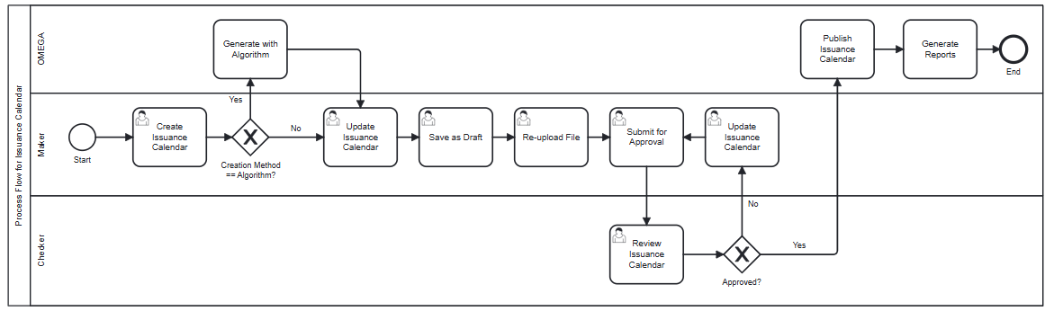
Figure 1: Activities when creating an issuance calendar
When creating an issuance calendar, the Maker selects the security type, year, period, and creation method. If the creation method is algorithm, OMEGA generates the issuance calendar based on the security type’s parameter settings. If it is not, user input (file upload or manual entry) is necessary.
The Maker reviews the issuance calendar and makes further updates if required, before saving it as a draft. The Maker can then export the issuance calendar to send to SGX and obtain the ISIN codes for the securities being issued. Once the exported issuance calendar is updated with the ISINs, the Maker re-uploads the issuance calendar into OMEGA before submitting for approval.
Upon submitting for approval, the Checker can view the issuance calendar and either approve or reject it. If the issuance calendar is approved, the issuance calendar is published based on the publication details set by the Maker. If the issuance calendar is rejected, the issuance calendar is sent back to the Maker for update. The update process is elaborated in Figure 2 below.
The figure below shows the high-level activities when updating an issuance calendar.
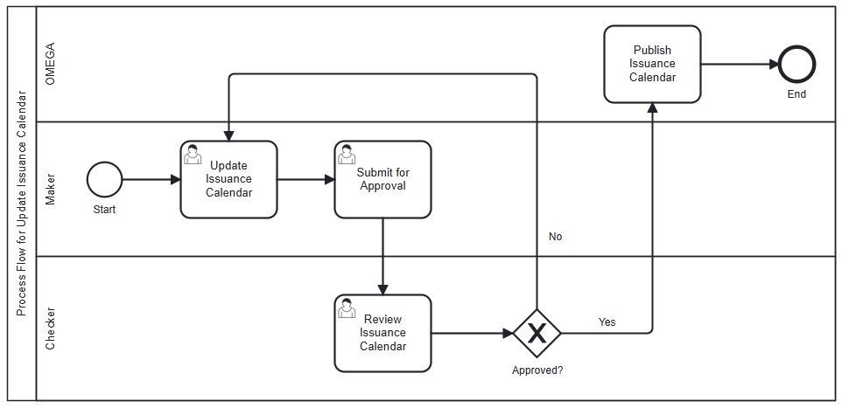
Figure 2: Activities when updating an issuance calendar
This process occurs if updates to the issuance calendar is necessary following an action by the Checker, such as after the Checker rejects the issuance calendar, or when the Maker requires an update after the Checker approves the issuance calendar. Updates can only be done via file upload and manual entry; updating with algorithm and saving as draft are not possible in this process. After making the necessary changes, the Maker submits the issuance calendar for approval again.
Similar to Figure 1, the Checker can view the issuance calendar and either approve or reject it. If the issuance calendar is approved, the issuance calendar is published based on the publication details set by the Maker. If the issuance calendar is rejected, the issuance calendar is sent back to the Maker for further updates.
Note: The issuance calendar for the selected Security type, Year, and Period is created (stored in the backend database) only when the maker saves it as draft or submits for approval.

BPMN Workflow
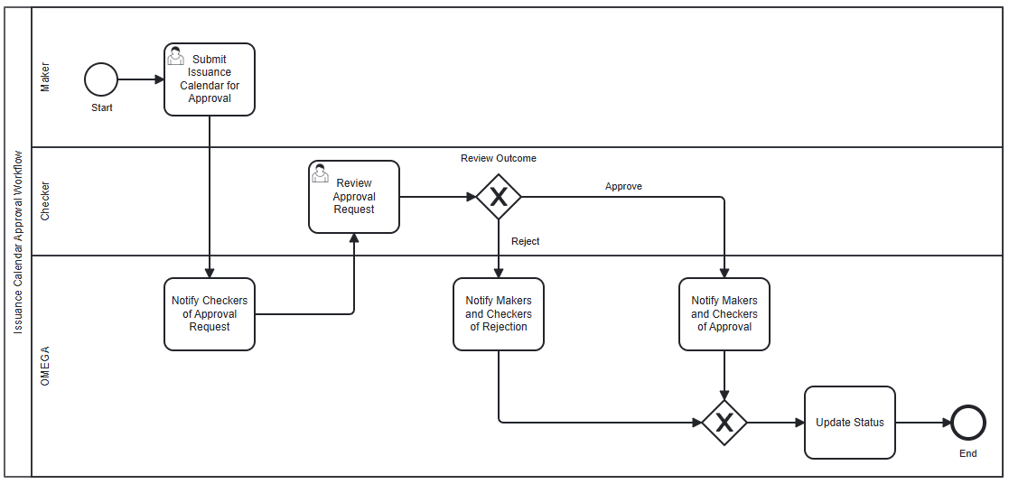
Figure 3: BPMN workflow for issuance calendars
In this module,
- An instance of the BPMN workflow above is created when a Maker submits an issuance calendar for approval.
- When an issuance calendar is submitted, OMEGA notifies the Checkers of the approval request that is pending their review.
- The Checker reviews the issuance calendar approval request with the option to approve or reject the request.
- When approved, the Makers and the Checkers are notified of the approved request, and OMEGA updates the status of the issuance calendar accordingly.
- When the request is rejected, the Makers and the Checkers are notified of the rejected request, and OMEGA reverts the status of the issuance calendar to its previous status. The only exception to the status reversion is if the previous status is Pending Publication, in which case the new status will be Rejected. In this scenario, for the particular security type, year and period, there are no changes to the existing issuance calendar data that was published on the MAS Website until it is updated again and approved.

State Transition Diagram
The figure below shows the possible status transitions that an issuance calendar may undergo, and the conditions required to trigger these transitions.
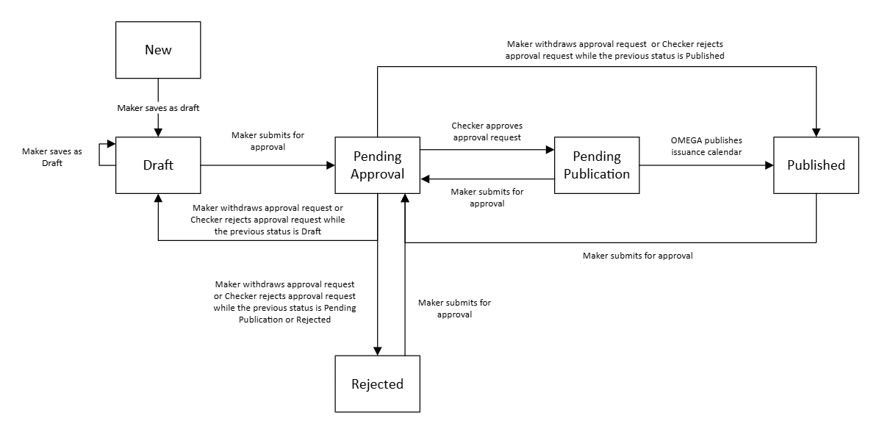
Figure 4: State transition diagram

Use Cases
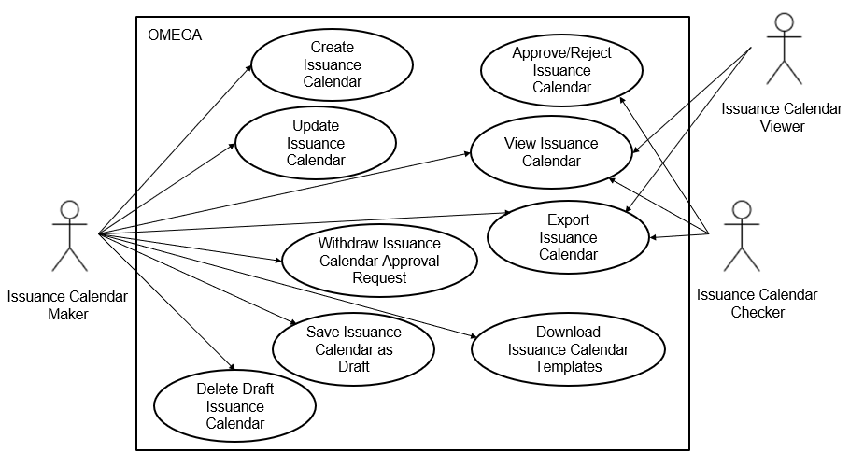
Figure 5: Use case diagram
The use cases covered within this module are:
- 2.7 View Issuance Calendar
- 2.8 Create Issuance Calendar
- 2.9 Update Issuance Calendar
- 2.10 Withdraw Issuance Calendar Approval
- 2.11 Save Issuance Calendar as Draft
- 2.12 Delete Draft Issuance Calendar
- 2.13 Approve/Reject Issuance Calendar
- 2.14 Export Issuance Calendar
- 2.15 Download Issuance Calendar Templates

View Issuance Calendar

Description
This use case enables users to view and filter issuance calendars.

Preconditions
- User logs in to the Intranet Portal.
- User accesses the Issuance Calendar Listing Page.

Business Requirements
- Role-based Access Control:
  - Issuance Calendar Maker – able to see all actions when the preconditions for the use case(s) are fulfilled.
  - Issuance Calendar Checker - is not able to see the actions Create calendar and Download templates.
  - Issuance Calendar Viewer - is not able to see the actions Create calendar and Download templates.

Post Conditions
- User views the issuance calendar details for a particular Security Type, Year, and Period.

Issuance Calendar Listing page
The Issuance Calendar Listing page contains the following screen elements:
- Page Header
- Data Table Action Bar
- Filter Drawer
- Data Table
Default Filter: Current year and next year.
Default Sorting: (1) descending order of year, (2) ascending order of security type, then (3) ascending order of period.

Wireframe
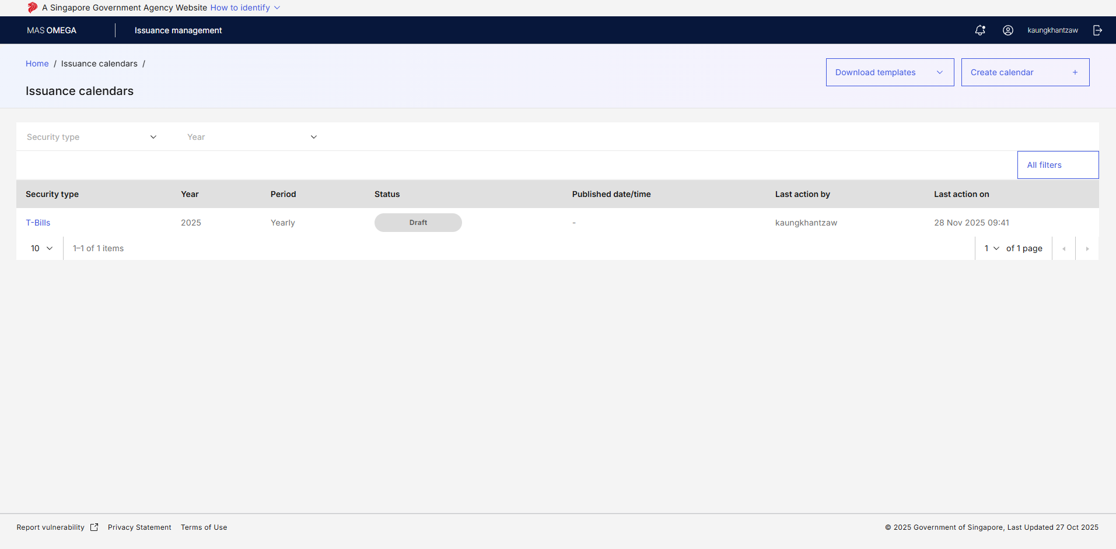
Figure 6: Issuance Calendar Listing Page

Page Header
S/N | Name | Type  (Max Length) | Validation Rules | Remarks
1 | Home / Issuance calendar / | Breadcrumb
2 | Issuance calendar | Page title
3 | Download templates | Tertiary button with Dropdown |  | Displays a dropdown containing issuance calendar templates of all active security types for download. Refer to 2.15 Download Issuance Calendar Templates.
4 | Create calendar | Tertiary button |  | Displays the Create Calendar Modal for creating a new issuance calendar. Refer to 2.8 Create Issuance Calendar.
Table 3: Page Header Screen Elements

Data Table Action Bar
S/N | Name | Type  (Max Length) | Validation Rules | Remarks
1 | Security type | Multiselect Dropdown |  | Options available are:  - SGS Bonds  - MAS Bills  - T-Bills  - SSBs  - CMTBs  Additional options are available based on the name when new security types are created.  Displays all security types regardless of its status.
2 | Year | Multiselect Dropdown |  | Options available are the 4-digit value of the years from the current year to the earliest year which an issuance calendar has been created.  Options are sorted in descending order.
Table 4: Data Table Action Bar Screen Elements

Filter Drawer
S/N | Name | Type  (Max Length) | Validation Rules | Remarks
1 | Year | Checkbox Group |  | Same options as in Data Table Action Bar.
2 | Period | Checkbox Group |  | Options available are:  - Yearly  - H1  - H2  - Q1  - Q2  - Q3  - Q4
3 | Security type | Multiselect Dropdown |  | Same options as in Data Table Action Bar.
Table 5: Filter Drawer Screen Elements
Refer to MAS_OMEGA – Functional Specifications Document (Common Functions).docx for the common screen elements and functionalities used in the Filter Drawer.

Data Table
S/N | Name | Type  (Max Length) | Validation Rules | Remarks
1 | Security type | Label (with hyperlink) |  | Clicking on the hyperlink navigates the user to the Issuance Calendar Details page based on the security type, year, and period of the row. Refer to 2.7.6 Issuance Calendar Details page.
2 | Year | Label
3 | Period | Label
4 | Status | Label |  | Refer to 2.5 State Transition Diagram for the possible values.
5 | Published date/time | Label |  | Displays this value if the status is “Published”. For all other statuses, display "-".
6 | Last action by | Label |  | Display the name of the user who made the last action that resulted in a change of status.  If it was an update by the system, “OMEGA” would be reflected as the user.
7 | Last action on | Label |  | Display the date and time of the last action that resulted in a change of status.
Table 6: Data Table Screen Elements

Issuance Calendar Details page
The Issuance Calendar Details page contains the following screen elements:
- Page Header
- Submission History
- Data Tables (Auctions/Allotment) – for all security types including SSBs.
- Data Table (Mini Auctions) – only for SGS Bonds.
- Data Table (Syndications) – only for SGS Bonds.
- Change Summary
- Footnotes
- Publication Details
- Internal Remarks
- Action Button Row
Default Sorting: (1) ascending order of announcement date, then (2) ascending order of tenor
Default Format for Date Fields: When viewing the Issuance Calendar Details page, the date fields in the data tables are rendered in “DD MMM YYYY ddd”. For example, “20 Oct 2025 Mon”. When editing, these date fields show the full day of the week, e.g. “20 Oct 2025 Monday”.
Display All Issuances Without Pagination: When viewing the data tables for Auctions/Allotments, Mini Auctions, and Syndications, the data tables display all data and do not have pagination. The data table for each issuance type is displayed in a separate tab.

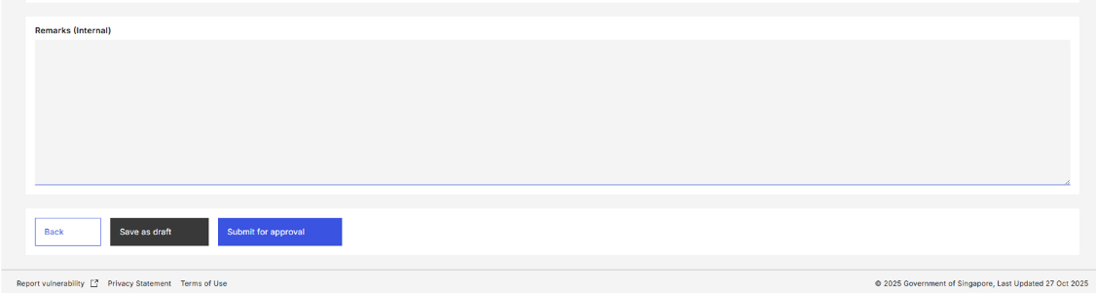
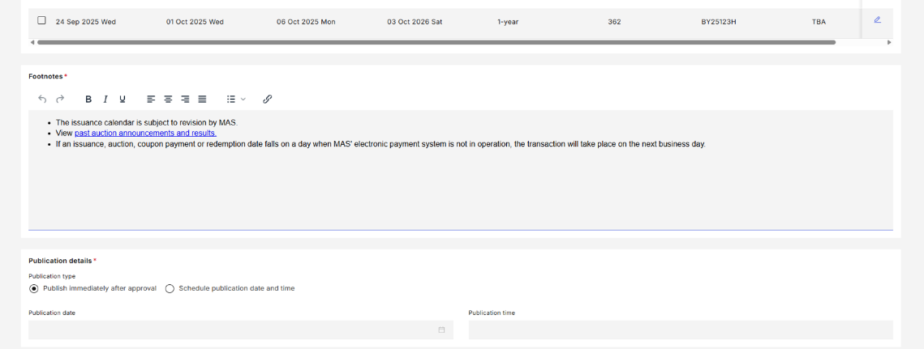
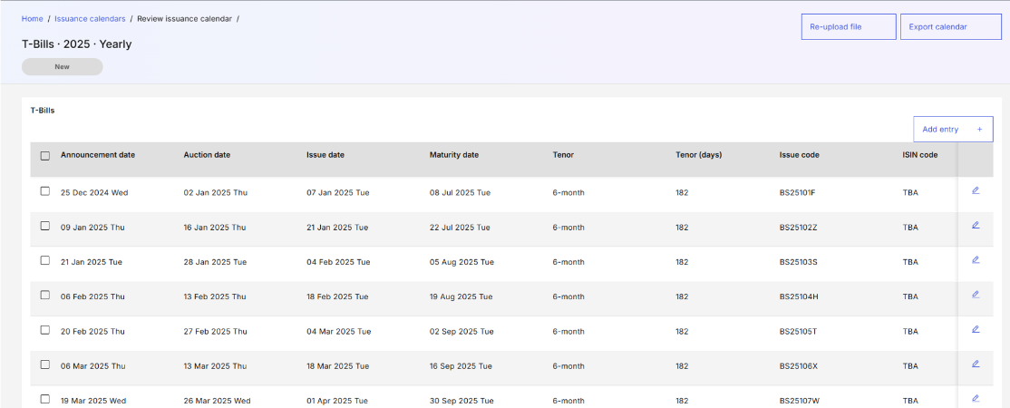
Wireframe
Figure 7: Issuance Calendar Details Page

Page Header
S/N | Name | Type  (Max Length) | Validation Rules | Remarks
1 | Title | Page Title |  | Displays the Security type, Year and Period of the issuance calendar as {securityType} · {year} · {period}", e.g. "SGS Bonds · 2025 · Yearly".
2 | Status | Status Pill Indicator |  | Displays the status of the issuance calendar. For example, .
3 | Export calendar | Tertiary button |  | Refer to 2.14 Export Issuance Calendar.
4 | Re-upload calendar | Tertiary button |  | Refer to 2.8.7 Re-upload Calendar Modal.
Table 7: Page Header Screen Elements

Submission History
The Submission History section is shown if the status of the issuance calendar is “Draft”, “Pending Approval”, “Pending Publication”, “Published”, or “Rejected”.
Refer to MAS_OMEGA – Functional Specifications Document (Common Functions).docx for the screen elements used and its functionalities.

Data Table (Auctions/Allotment)
Empty Values in Date Fields: For all fields which are Date Pickers (when editing), display as “TBA” when viewing and subsequently for Checker/MAS Website if the date field is left empty.
A label is shown above the Data Table: “Empty date fields will be reflected as TBA for the Checker and MAS website.”.
S/N | Name | Type  (Max Length) | Validation Rules | Remarks
1 | Announcement date | Date Picker (when editing)  Label (when viewing) | Hard Validations:  - Required field.  - Must be on or before Auction /Allotment date.  Soft Validations:  - Non-SSBs: Should be {X} business days before Issue date.  - SSBs: Should be the 1st business day of the previous month from Issue date.  - MAS Bills: Should follow the Announcement date of other tenors issued on the same week.  - Should be a business day. | {X} is the value of the “Announcement day (T-X business days)” parameter for the following security types:  • SGS Bonds  • T-Bills  • MAS Bills  • SSB
2 | Auction/Allotment date | Date Picker (when editing)  Label (when viewing) | Hard Validations:  - Required field.  - Must be on or before Issue Date.  Soft Validations:  - Should be {X} business days before Issue date.  - MAS Bills: Should follow the Auction/Allotment date of other tenors issued on the same week.  - Should be a business day. | Will only show “Allotment date” for SSB, and “Auction date” for other security types.  {X} is the value of the “Auction day (T-X business days)” parameter for the following security types:  • SGS Bonds  • T-Bills  • MAS Bills  • SSB  Soft validations do not apply to SSBs and CMTBs.
3 | Issue date | Date Picker (when editing)  Label (when viewing) | Hard Validations:  - Required field.  - Must be before Maturity Date.  Soft Validations:  - SGS Bonds and SSBs: Should be on the {X} business day(s) of the month.  - T-Bills and MAS Bills: Should be on {Y}.  - MAS Bills: Should fall on a past Maturity Date of the same tenor.  - Should be a business day. | {X} is the value of the “Primary issue/maturity day (T)” parameter for the following security types:  - SGS Bonds  - SSBs  {Y} is a derivation of the value of the “Primary issue/maturity day (T)” and the “Offset from primary issue day” parameters of following security types:  - T-Bills  - MAS Bills  For example, if the “Primary issue/maturity day (T)” is Friday and the “Offset from primary issue day” is -1, then the Issue date/settlement date should be on a Thursday.
4 | Maturity date | Date Picker (when editing)  Label (when viewing) | Hard Validations:  - Required field.  - For Reopened SGS: Should be same as the Maturity Date of the original issue.  Soft validations:  - SSBs and New SGS: Should be on the 1st of the same month of the Issue date plus the tenor.  - T-Bills: Should fall on {X}.  - MAS Bills: Should be a business day. | {X} is the value of the “Primary issue/maturity day (T)” parameter for the following security types:  - T-bills  - SSBs  SGS Bond (New)
5 | Tenor | Dropdown (when editing)  Label (when viewing) | Hard Validations:  - Required field. | Available options are based on the list of tenors for the security type.  Options available for SGS Bonds:  - 2-year  - 5-year  - 10-year  - 15-year  - 20-year  - 30-year  - 40-year  - 50-year  Options available for T-Bills:  - 6-month  - 1-year  Options available for SSBs:  - 10-year  Options available for MAS Bills:  - 4-week  - 12-week  - 36-week  Options available for CMTBs:  - 7-day  Additional options are available based on security type when new security types or new tenors for existing security types are created.
6 | Tenor (days) | Label | - | Computed by OMEGA and not required to be submitted by users.  Only visible for MAS Bills, T-bills and CMTB.  Value is number of calendar days between Maturity date and Issue date.
7 | Issue code | Text Input (when editing)  Label (when viewing)  Max length: 8 | Hard Validations:  - Required field.  - Invalid Issue code.  If Issue code is unavailable, key as "TBA". | Refer to Logic For Issue Code.pdf for the validation logic.  The prefix for the Issue code is the value of the “Issue code prefix” parameter.
8 | ISIN code | Text Input (when editing)  Label (when viewing)  Max length: 12 | Hard Validations:  - Invalid ISIN code. If ISIN is unavailable, key ISIN as "TBA" or “TBC”.  - For Reopened SGS: Must be same as the ISIN code of the original issue.
9 | New/reopen | Dropdown (when editing)  Label (when viewing) | Hard Validations:  - Required field. | Only visible and mandatory for SGS Bonds.  Options available are:  - New  - Reopen
10 | Benchmark | Dropdown (when editing)  Label (when viewing) | Hard Validations:  - Required field. | Only visible and mandatory for SGS Bonds.  Options available are:  - Yes  - No
11 | SGS type | Dropdown (when editing)  Label (when viewing) | Hard Validations:  - Required field.  - For Reopened SGS: Must be same as the SGS type of the original issue. | Will show “SGS type” if the security is a SGS Bond, and “Subtype” for created securities with subtypes.  Visible and mandatory if the security is a SGS Bond or has subtypes.  Available options are based on the list of subtypes for the security type.
12 | Closing date | Date Picker (when editing)  Label (when viewing) | Hard Validations:  - Required field.  - Must be on or before Allotment date.  Soft Validations:  - Should be 1 business day before Allotment Date. | Only visible and mandatory for SSBs and other security types created whose bid collation occurs over the month.
13 | CDP naming convention | Label |  | Only visible for SSBs.  The CDP naming convention is derived based on “SB<MMM><YY> <Issue Code>” where <MMM> and <YY> is the month and year of the Issue Date. For example, “SBFEB24 GX24020T” is a valid CDP Naming Convention.
Table 8: Data Table (Auctions) Screen Elements

Data Table (Mini Auctions)
Empty Values in Date Fields: For all fields which are Date Pickers (when editing), display as “TBA” when viewing and subsequently for Checker/MAS Website if the date fields are left empty.
A label is shown above the Data Table: “Empty date fields will be reflected as TBA for the Checker and MAS website.”
S/N | Name | Type  (Max Length) | Validation Rules | Remarks
1 | Bond announcement date | Date Picker (when editing)  Label (when viewing) | Hard Validations:  - Required field.  - Must be before Size announcement date.  Soft Validations:  - Should be a business day.
2 | Size announcement date | Date Picker (when editing)  Label (when viewing) | Hard Validations:  - Required field.  - Must be on or before Auction date.  Soft Validations:  - Should be {X} business days before Issue date.  - Should be a business day. | {X} is a configurable parameter for SGS Bonds with an initial value of 7.
3 | Auction date | Date Picker (when editing)  Label (when viewing) | Hard Validations:  - Required field.  - Must be on or before Issue Date.  Soft Validations:  - Should be {X} business days before Issue date.  - Should be a business day. | {X} is a configurable parameter for SGS Bonds with an initial value of 3.
4 | Issue date | Date Picker (when editing)  Label (when viewing) | Hard Validations:  - Required field.  - Must be before Maturity date.  Soft Validations:  - Should be on the {X} business day(s) of the month.  - Should be a business day. | {X} is a configurable parameter for SGS Bonds with an initial value of 1.
5 | Maturity date | Date Picker (when editing)  Label (when viewing) | Hard Validations:  - Required field.  - For Reopened SGS: Should be same as the Maturity Date of the original issue.  Soft validations:  - SGS (New): Should be on the 1st of the same month of the Issue Date plus the tenor. | If empty, display as “TBA”.
6 | Tenor | Dropdown (when editing)  Label (when viewing) | Hard Validations:  - Required field. | Options available are:  - TBA  - 2-year  - 5-year  - 10-year  - 15-year  - 20-year  - 30-year  - 40-year  - 50-year  Dropdown defaults to TBA.  Additional options are available in the format {number}-{unit} when new tenors are created.
7 | Issue code | Text Input (when editing)  Label (when viewing)  Max length: 8 | Hard Validations:  - Invalid Issue code  If Issue code is unavailable, key as "TBA". | Refer to Logic For Issue Code.pdf for the validation logic.  The prefix for the Issue code is a configurable parameter based on the security type, tenor, and security subtypes.
8 | ISIN code | Text Input (when editing)  Label (when viewing)  Max length: 12 | Hard Validations:  - Invalid ISIN code. If ISIN is unavailable, key ISIN as "TBA" or “TBC”.  - For Reopened SGS: Must be same as the ISIN code of the original issue.
9 | New/reopen | Dropdown (when editing)  Label (when viewing) | Hard Validations:  - Required field. | Options available are:  - TBA  - New  - Reopen  Dropdown defaults to TBA.
10 | Benchmark | Dropdown (when editing)  Label (when viewing) | Hard Validations:  - Required field. | Options available are:  - TBA  - Yes  - No  Dropdown defaults to TBA.
11 | SGS type | Dropdown (when editing)  Label (when viewing) | Hard Validations:  - Required field.  - For Reopened SGS: Must be same as the SGS type of the original issue. | Options available are:  - TBA  - SGS (MD)  - SGS (Infra)  - Green SGS (Infra)  Dropdown defaults to TBA.  Additional options are available based on the name of the SGS type if new SGS types are created.
Table 9: Data Table (Mini Auctions) Screen Elements

Data Table (Syndications)
Empty Values in Date Fields: For all fields which are Date Pickers (when editing), display as “TBA” when viewing and subsequently for Checker/MAS Website if the date fields are left empty.
A label is shown above the Data Table: “Empty date fields will be reflected as TBA for the Checker and MAS website.”.
S/N | Name | Type  (Max Length) | Validation Rules | Remarks
1 | Pricing date | Date Picker (when editing)  Label (when viewing) | Hard Validations:  - Must be on or before Public offer start date.  Soft Validations:  - Should be a business day. | If empty, display as “TBA”.
2 | Public offer start date | Date Picker (when editing)  Label (when viewing) | Hard Validations:  - Must be on or before Public offer end date.  Soft Validations:  - Should be a business day. | If empty, display as “TBA”.
3 | Public offer end date | Date Picker (when editing)  Label (when viewing) | Hard Validations:  - Must be before Issue date.  Soft Validations:  - Should be a business day. | If empty, display as “TBA”.
4 | Allotment date | Date Picker (when editing)  Label (when viewing) | Hard Validations:  - Must be on or before Issue date.  Soft Validations:  - Should be a business day. | If the Public offer end date changes and this field is empty, set the value of this field to 1 business day after the Public offer end date.
5 | Issue date | Date Picker (when editing)  Label (when viewing) | Hard Validations:  - Must be before Maturity date.  Soft Validations:  - Should be a business day. | If empty, display as “TBA”.
6 | Maturity date | Date Picker (when editing)  Label (when viewing) | Hard Validations:  - Required field.  - For Reopened SGS: Should be same as the Maturity Date of the original issue.  Soft validations:  - SGS (New): Should be on the 1st of the same month of the Issue Date plus the tenor. | If empty, display as “TBA”.
7 | Tenor | Dropdown (when editing)  Label (when viewing) |  | Options available are:  - TBA  - 2-year  - 5-year  - 10-year  - 15-year  - 20-year  - 30-year  - 40-year  - 50-year  Dropdown defaults to TBA.  Additional options are available in the format {number}-{unit} when new tenors are created.
8 | Issue code | Text Input (when editing)  Label (when viewing)  Max length: 8 | Hard Validations:  - Invalid Issue code. If Issue code is unavailable, key as "TBA". | Refer to Logic For Issue Code.pdf for the validation logic.  The prefix for the Issue code is a configurable parameter based on the security type, tenor, and security subtypes.
9 | ISIN code | Text Input (when editing)  Label (when viewing)  Max length: 13 | Hard Validations:  - Invalid ISIN code. If ISIN is unavailable, key ISIN as "TBA" or “TBC”.  - For Reopened SGS: Must be same as the ISIN code of the original issue. | Filled with alphanumeric value of max length 13, with an optional last character of “*”. If this character is present, indicate that the ISIN is provisional when publishing to the MAS website.
10 | New/reopen | Dropdown (when editing)  Label (when viewing) | Hard Validations:  - Required field. | Options available are:  - TBA  - New  - Reopen  Dropdown defaults to TBA.
11 | Benchmark | Dropdown (when editing)  Label (when viewing) | Hard Validations:  - Required field. | Options available are:  - TBA  - Yes  - No  Dropdown defaults to TBA.
12 | SGS type | Dropdown (when editing)  Label (when viewing) | Hard Validations:  - Required field.  - For Reopened SGS: Must be same as the SGS type of the original issue. | Options available are:  - TBA  - SGS (MD)  - SGS (Infra)  - Green SGS (Infra)  Dropdown defaults to TBA.  Additional options are available based on the name of the SGS type if new SGS types are created.
Table 10: Data Table (Syndications) Screen Elements

Change Summary
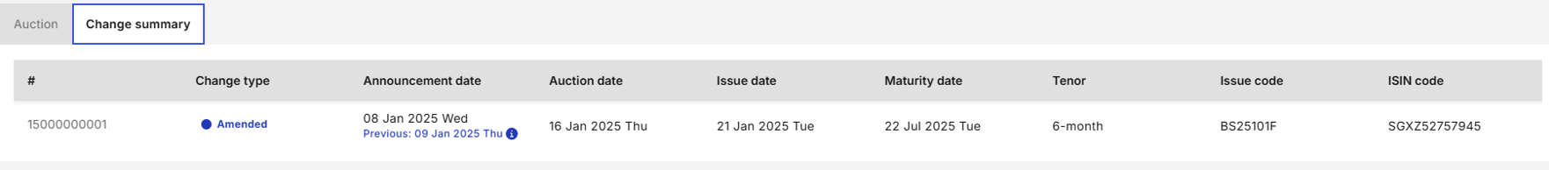
Figure 8: Change Summary
The Change Summary is a tab that is visible to Viewers, Makers, and Checkers if the status of the issuance calendar is “Pending approval”. The primary purpose of this screen element is to indicate the rows that are added, deleted, or edited. One data table is shown for each issuance type of the security type.
The columns follow the screen elements listed in 2.7.6.4 Data Table (Auctions/Allotment), 2.7.6.5 Data Table (Mini Auctions), and 2.7.6.6 Data Table (Syndications), with the following exceptions:
- There are two additional columns, “#”, that indicates the row number of the row being inserted, amended, or deleted, and “Change type”, that indicates whether the row is an amendment, new entry, or deleted entry.
- If there is an amendment in a particular field value, the current value and the previous value (in the following line) are shown.
- Tables in this tab are read-only and cannot be edited by any user.

Footnotes
S/N | Name | Type  (Max Length) | Validation Rules | Remarks
1 | Footnotes | Rich Text Editor Max length: 4000 | Hard Validations:  - Required field. | Defaults to the footnote value for the issuance calendar of the same security type of the previous year and period.
Table 11: Footnotes Screen Elements

Publication Details
S/N | Name | Type  (Max Length) | Validation Rules | Remarks
1 | Publication option | Radio Button Group |  | Options available are:  - Publish immediately  - Publish at specific date/time
2 | Publication date | Date Picker |  | To display when the option ‘Publish at specific date/time is selected. Mandatory and editable only if "Publish at specific date/time" is selected as the Publication Timing. Defaults to current date.
3 | Publication time | Time Picker |  | To display when the option ‘Publish at specific date/time is selected. Mandatory and editable only if "Publish at specific date/time" is selected as the Publication Timing.  The default value for this field is a configurable parameter. See Issuance calendar publication time in Configurations in xxx.
Table 12: Publication Details Screen Elements

Internal Remarks
Refer to MAS_OMEGA – Functional Specifications Document (Common Functions).docx for the screen elements used and its functionalities.

Action Button Row
S/N | Name | Type  (Max Length) | Validation Rules | Remarks
1 | Back | Tertiary button |  | Redirects the user back to the Issuance Calendar Listing Page.
2 | Save as draft | Secondary button |  | Saves the issuance calendar details as a draft. Refer to 2.11 Save Issuance Calendar as Draft.
3 | Submit for approval | Primary button |  | Submits the issuance calendar for approval. Refer to 2.8 Create Issuance Calendar if the issuance calendar is submitted for approval for the first time, or 2.9 Update Issuance Calendar if it had been previously approved.
Table 13: Action Button Row Screen Elements

Create Issuance Calendar

Description
This use case enables Makers to create issuance calendars.

Preconditions
- User logs in to the Intranet Portal.
- User accesses the Issuance Calendar Listing Page.
- No issuance calendar for the particular Security type, Year, and Period has been created.

Business Requirements
- Role-based Access Control:
  - Issuance Calendar Maker
- Click on the Create calendar button in the Issuance Calendar Listing page to open the Create Calendar Modal.
- Default Option for Create Calendar Modal: If there is only one available option for the Period field, set it as the default value.
- Creation Methods: Only the following securities can be created by algorithm: SSBs, MAS Bills and T-bills. For the algorithm logic, refer to Section 3 Logic for Creation of Issuance Calendars via Algorithm.
- No Duplicates or Overlap of Period: Only one issuance calendar can be created for a particular Security type, Year and Period. In addition, the Period cannot overlap for the same Security type and Year. For example, if H1 is created for a particular Security type and Year, the Yearly, H1, Q1, and Q2 options cannot be created.
- Special Handling for File Uploads: If the uploaded file does not contain the tab for a specific issuance type, OMEGA assumes that there is no change to the data for that issuance type. To remove all existing data in the issuance calendar, the maker must upload the tab for the issuance type while leaving the field values empty.

Post Conditions
- An instance of the BPMN workflow is created.
- The status of the issuance calendar is updated to “Pending Approval”.
- The event is added to the audit log and submission history.
- Emails and notifications are sent to the checkers to inform them of the issuance calendar which was submitted for approval.
- User is redirected back to the Issuance Calendar Listing page.
- User views a temporary toast notification informing that the approval request was sent.

Create Issuance Calendar Modal
All methods to create an issuance calendar should be displayed regardless of security type. If a particular security type cannot be generated by an algorithm, the option is disabled, with a message “Algorithmic generation is not supported for this security type” displayed.
If the “File upload” option is selected as the creation method, the following file-level validations apply:
- Check if the file exceeds the file size limit;
- Check if the file is readable as an Excel file; and
- Check if the file template matches the security type.
If any of the above validations fail to be met, an inline non-closable toast notification appears, and the Maker remains at the Create Issuance Calendar Modal.
If all file level validations are met, the Maker is redirected to the Issuance Calendar Details Page. For each field, the following field-level validations apply:
- Check if the format of the field value matches the template for the security type.
If any of the above validation fail to be met, the value of the field will be empty. Otherwise, the value of the field will display the value in the uploaded file. If any field fails a hard validation, an error message is displayed below the field value. If any field passes all hard validations but fails a soft validation, a warning message is displayed below the field value.

Wireframe
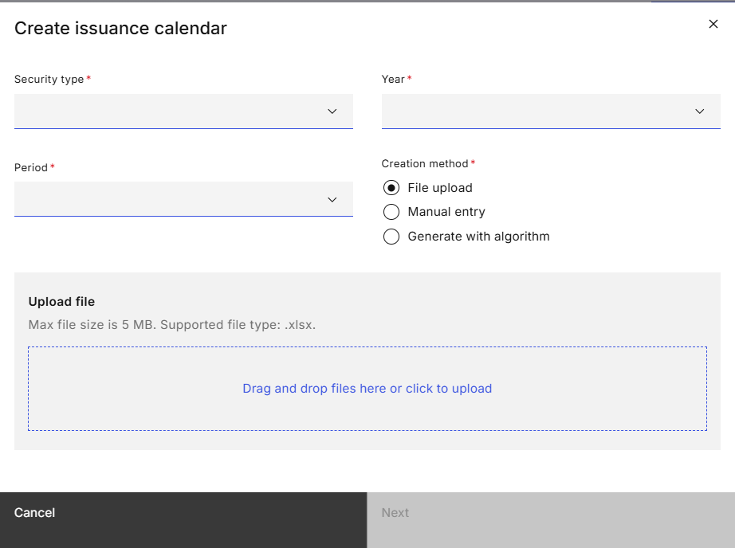
Figure 9: Create Issuance Calendar Modal

Screen Elements
S/N | Name | Type  (Max Length) | Validation Rules | Remarks
1 | Create issuance calendar | Modal Title
2 | Security type | Dropdown |  | Options available are:  - SGS Bonds  - MAS Bills  - T-Bills  - SSBs  - CMTBs  Options available are based on the status of the security type. Only active security types are displayed.
3 | Year | Dropdown |  | The options available include the current year and the following year.  For example, if the year is 2025, the following options are available:  - 2026  - 2025
4 | Period | Dropdown |  | Options available are:  - Yearly  - H1  - H2  - Q1  - Q2  - Q3  - Q4  A subset of these options are available based on the configurable parameters of the security type. For example, MAS Bills are set to semi-annually (i.e. options available are “H1” and “H2”, while the other securities are “Yearly”.
5 | Creation method | Radio Button Group |  | Options available are:  - File upload  - Manual entry  - Generate with algorithm
6 | Upload file | File Upload Container |  | Only visible and mandatory when the creation method selected is "File Upload".
7 | Next | Primary button |  | Redirects the user to the Issuance Calendar Details page.  Disabled if there is no input in the mandatory fields.
8 | Cancel | Secondary button |  | Closes the Create Issuance Calendar Modal.
Table 14: Create Calendar Modal Screen Elements

Issuance Calendar Details page
Refer to 2.7.6 for the screen elements in the Issuance Calendar Details page. For 2.8 Create Issuance Calendar, the page contains additional elements in the Action Button Row.

Wireframe
Refer to 2.7.6.1 Wireframe.

Action Button Row
S/N | Name | Type  (Max Length) | Validation Rules | Remarks
1 | Save as draft | Secondary button |  | Saves the issuance calendar as draft. Refer to 2.11 Save Issuance Calendar as Draft.
2 | Submit for approval | Primary button |  | Opens the confirmation prompt.  Disabled if mandatory fields not filled.
Table 15: Action Button Row Screen Elements

Upload ISIN Modal
Makers can choose to update the ISIN by re-uploading the calendar. The following file-level validations apply:
- Check if the file exceeds the file size limit;
- Check if the file is readable as an Excel file;
- Check if the file template matches the security type;

- For each tab in the uploaded file, check if the number of rows in the Issuance Calendar Details page for the corresponding data table matches the number of rows in the tab of the uploaded file.
If all validations pass, for each row in the uploaded file, update the ISIN code field based on the issue code and issue date.
If the uploaded file does not contain the tab for a specific issuance type, OMEGA assumes that there is no change to the data for that issuance type. If the validation fails, an inline non-closable toast notification appears, and the Maker remains at the Upload ISIN Modal. No change to the existing data in any data table of the Issuance Calendar Details Page is made.

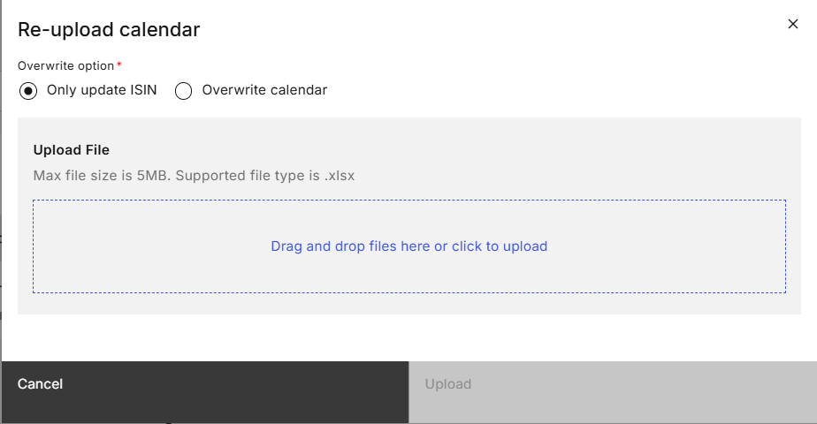
Figure 10: Re-upload Calendar Modal
S/N | Name | Type  (Max Length) | Validation Rules | Remarks
1 | Upload ISIN | Modal title
2 | Overwrite option | Radio button group |  | Options available are:  - Only update ISIN  - Overwrite calendar
3 | Upload file | File upload container |  | Refer to MAS_OMEGA – Functional Specifications Document (Common Functions).docx.
4 | Next | Primary button |  | Redirects the user to the Issuance Calendar Details page.  Disabled if no file uploaded in file container.  Updates and validates the issuance calendar’s ISIN code from the values in the file based on Issue code and issue date. All hard and soft validations related to ISIN code under section 2.7.6.4, 2.7.6.5 and 2.7.6.6 will be applicable.
5 | Cancel | Secondary button |  | Closes the Re-upload Calendar Modal.
Table 16: Re-upload Calendar Modal Screen Elements

Confirmation Prompt
All fields in this modal are non-editable. Any amendments to the issuance calendar are made at the Issuance Calendar Details page.

Wireframe

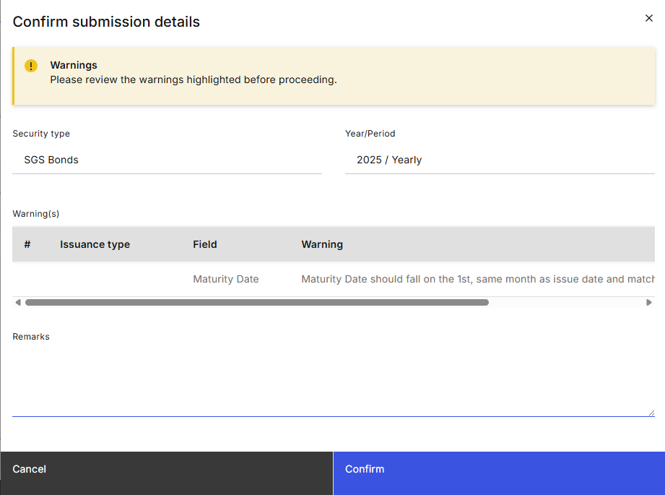
Figure 11: Confirmation Prompt

Confirmation Prompt
S/N | Name | Type  (Max Length) | Validation Rules | Remarks
1 | Confirm submission details | Modal Title
2 | Warning banner | Warning Inline Notification without Close Button |  | The following is displayed if there is at least one warning.  “Warnings  Please review the warning(s) before proceeding.”
3 | Security type | Label
4 | Year / Period | Label
5 | Warning(s) | Data Table |  | Displayed if there is at least one warning.  Displays the row number, issuance type, field name and value as well as the soft warning applicable for the field.
6 | Submit | Primary button |  | Submits the issuance calendar for approval. Refer to 2.8.4 Post Conditions.
7 | Cancel | Secondary button |  | Closes the Confirmation Prompt.
Table 17: Confirmation Prompt Screen Elements

Update Issuance Calendar

Description
This use case enables Makers to update issuance calendars.

Preconditions
- User logs in to the Intranet Portal.
- User accesses the Issuance Calendar Listing Page.
- An issuance calendar for the particular Security type, Year, and Period has already been created.
- The status of the issuance calendar is “Pending Publication”, “Published”, or “Rejected”.

Business Requirements
- Role-based Access Control:
  - Issuance Calendar Maker
- Cancellation of Mini-Auction: If published mini-auctions are subsequently cancelled on the bond announcement date, the issuance calendar in OMEGA is updated to remove the mini-auction but the MAS website still displays the same number of records, indicating “No mini auction” in the bond announcement date for cancelled auctions.
- Special Handling for File Uploads: If the uploaded file does not contain the tab for a specific issuance type, OMEGA assumes that there is no change to the data for that issuance type. To remove all existing data in the issuance calendar, the Maker must upload the tab for the issuance type while leaving the field values empty.

Post Conditions
- An instance of the BPMN workflow is created.
- The status of the issuance calendar is updated to “Pending Approval”.
- The event is added to the audit log and submission history.
- Emails and notifications are sent to the checkers to inform them of the issuance calendar which was submitted for approval.
- User is redirected back to the Issuance Calendar Listing page.
- User views a temporary toast notification informing that the approval request was sent.

Issuance Calendar Details page
Refer to 2.7.6 for the screen elements in the Issuance Calendar Details page. For 2.9 Update Issuance Calendar, the page contains additional elements in the Page Header and the Action Button Row.

Wireframe
Refer to 2.7.6.1 Wireframe.

Page Header
S/N | Name | Type  (Max Length) | Validation Rules | Remarks
1 | Re-upload calendar | Tertiary button |  | Opens the re-upload calendar modal.
Table 18: Page Header Screen Elements

Action Button Row
S/N | Name | Type  (Max Length) | Validation Rules | Remarks
1 | Next | Primary button |  | Opens the confirmation prompt.  Disabled if mandatory fields not filled.
Table 19: Action Button Row Screen Elements

Upload ISIN Modal
Refer to 2.8.7 Upload ISIN Modal.

Confirmation Prompt
Refer to 2.8.8 Confirmation Prompt.

Withdraw Issuance Calendar Approval

Description
This use case enables Makers to withdraw issuance calendar approval requests.

Preconditions
- User logs in to the Intranet Portal.
- User accesses the Issuance Calendar Listing Page.
- An issuance calendar for the particular Security type, Year, and Period has been created.
- The status of the issuance calendar is “Pending Approval”.

Business Requirements
- Role-based Access Control:
  - Issuance Calendar Maker

Post Conditions
- The instance of the BPMN workflow that was created when the issuance calendar was submitted for approval is suspended.
- The status of the issuance calendar is updated based on its previous status, refer to 2.5 State Transition Diagram.
- The event is added to the audit log and submission history.
- Emails are sent to the Checkers to inform them of the issuance calendar which was withdrawn.
- User is redirected back to the Issuance Calendar Listing page.
- User views a temporary toast notification informing that the withdrawal was successful.

Issuance Calendar Details page
Refer to 2.7.6 for the screen elements in the Issuance Calendar Details page. For 2.10 Withdraw Issuance Calendar Approval, the page contains additional elements in the Page Header.

Wireframe
Refer to 2.7.6.1 Wireframe.

Page Header
S/N | Name | Type  (Max Length) | Validation Rules | Remarks
1 | Withdraw | Tertiary button |  | Opens the confirmation prompt.
Table 21: Page Header Screen Elements

Confirmation Prompt
All fields in this modal are non-editable.

Wireframe
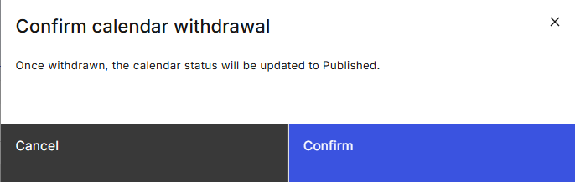
Figure 13: Confirmation Prompt

Confirmation Prompt
S/N | Name | Type  (Max Length) | Validation Rules | Remarks
1 | Confirm calendar withdrawal | Modal title
2 | Once withdrawn, the calendar will be updated to {status}. | Modal description |  | {status} is the status of the issuance calendar after the withdrawal. Refer to 2.5 State Transition Diagram.
3 | Confirm | Primary button |  | Withdraws the approval request submitted for this issuance calendar. Refer to 2.10.4 Post Conditions.
4 | Cancel | Secondary button |  | Closes the Confirmation Prompt.
Table 22: Confirmation Prompt Screen Elements

Save Issuance Calendar as Draft

Description
This use case enables Makers to save issuance calendars as drafts. This is typically used when the issuance calendar is not ready to be sent for approval at the point in time i.e., awaiting SGX to provide the ISIN Code.

Preconditions
- User logs in to the Intranet Portal.
- User accesses the Issuance Calendar Listing Page.
- An issuance calendar for the particular Security type, Year, and Period has been or is being created.
- The status of the issuance calendar is “New” or “Draft”.

Business Requirements
- Role-based Access Control:
  - Issuance Calendar Maker

Post Conditions
- The status of the issuance calendar is updated to “Draft”.
- The event is added to the audit log and submission history.
- User remains in the Issuance Calendar Details page.
- User views a temporary toast notification informing that the save as draft was successful.

Issuance Calendar Details page
Refer to 2.7.6 for the screen elements in the Issuance Calendar Details page. For 2.11 Save Issuance Calendar as Draft, the page contains additional elements in the Action Button Row.

Wireframe
Refer to 2.7.6.1 Wireframe.

Action Button Row
S/N | Name | Type  (Max Length) | Validation Rules | Remarks
1 | Save as draft | Secondary button |  | Opens the confirmation prompt.
Table 23: Action Button Row Screen Elements

Confirmation Prompt
All fields in this modal are non-editable.

Wireframe
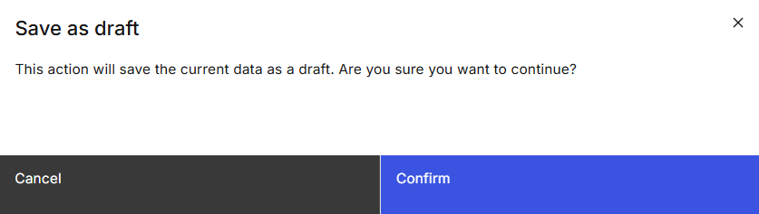
Figure 14: Confirmation Prompt

Confirmation Prompt
S/N | Name | Type  (Max Length) | Validation Rules | Remarks
1 | Save as draft | Modal title
2 | This action will save the current data as a draft. Are you sure you want to continue? | Modal description
3 | Confirm | Primary button |  | Saves the issuance calendar data as draft. Refer to 2.11.4 Post Conditions.
4 | Cancel | Secondary button |  | Closes the Confirmation Prompt.
Table 24: Confirmation Prompt Screen Elements

Delete Draft Issuance Calendar

Description
This use case enables Makers to delete draft issuance calendar.

Preconditions
- User logs in to the Intranet Portal.
- User accesses the Issuance Calendar Listing Page.
- An issuance calendar for the particular Security type, Year, and Period has been created.
- The status of the issuance calendar is “Draft”.

Business Requirements
- Role-based Access Control:
  - Issuance Calendar Maker
- Issuance calendars whose drafts are deleted can be subsequently re-created even if it shares the same Security type, Year, and Period.

Post Conditions
- The event is added to the audit log and submission history.
- User is redirected back to the Issuance Calendar Listing page.
- User views a temporary toast notification informing that the deletion of the draft was successful.
- The deleted draft cannot be seen in the Issuance Calendar listing page.

Issuance Calendar Details page
Refer to 2.7.6 for the screen elements in the Issuance Calendar Details page. For 2.12 Delete Draft Issuance Calendar, the page contains additional elements in the Action Button Row.

Wireframe
Refer to 2.7.6.1 Wireframe.

Action Button Row
S/N | Name | Type  (Max Length) | Validation Rules | Remarks
1 | Delete draft | Tertiary button |  | Opens the confirmation prompt.
Table 25: Action Button Row Screen Elements

Confirmation Prompt
All fields in this modal are non-editable.

Wireframe
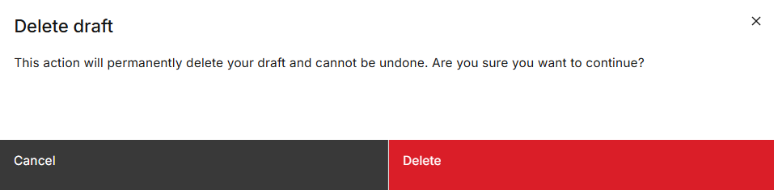
Figure 15: Confirmation Prompt

Confirmation Prompt
S/N | Name | Type  (Max Length) | Validation Rules | Remarks
1 | Delete draft | Modal title
2 | This action will permanently delete your draft and cannot be undone. Are you sure you want to continue? | Modal description
3 | Confirm | Primary danger button |  | Deletes the draft issuance calendar. Refer to 2.12.4 Post Conditions.
4 | Cancel | Secondary button |  | Closes the Confirmation Prompt.
Table 26: Confirmation Prompt Screen Elements

Approve/Reject Issuance Calendar

Description
This use case enables Checkers to approve or reject issuance calendars.

Preconditions
- User logs in to the Intranet Portal.
- User accesses the Issuance Calendar Details Page.
- An issuance calendar for the particular Security type, Year, and Period was created.
- The issuance calendar is of the status “Pending Approval”.

Business Requirements
- Role-based Access Control:
  - Issuance Calendar Checker
- Checkers are not allowed to approve or reject the issuance calendars which they have submitted for approval. as they may hold both maker and checker roles.
- Checkers must enter remarks before being able to reject issuance calendars.
- If Checkers approve the issuance calendar after the set publication date/time, the issuance calendar is published immediately.

Post Conditions
- The issuance calendar is either:
  - approved and either published immediately or at the scheduled publication time, OR
  - rejected and reverted to its previous status (if the previous status is not “Pending Publication” or “Rejected”), OR
  - rejected and its status is changed to “Rejected” (if the previous status is “Pending Publication” or “Rejected”).
- On the set publication date/time, OMEGA sends the approved issuance calendar details to the MAS Website, Retail PDs and CDP. Refer to the MAS_OMEGA – Interface Specifications Document (MAS Website).docx and MAS_OMEGA – Interface Specifications Document (FIs and CDP).docx for more details.
- Emails are sent to inform users that the issuance calendar has been approved or rejected.
- Emails are also sent upon publication of the issuance calendar.
- User views a temporary toast notification informing that the approval or rejection was successful.

Issuance Calendar Details page
Refer to 2.7.6 for the screen elements in the Issuance Calendar Details page. For 2.13 Approve/Reject Issuance Calendar, the page contains additional elements in the Action Button Row.
The fields in this page are read-only to the Checkers except for the “Remarks (internal)” field.

Wireframe
Refer to 2.7.6.1 Wireframe.

Action Button Row
S/N | Name | Type  (Max Length) | Validation Rules | Remarks
1 | Reject | Secondary button |  | Opens the confirmation prompt.  Disabled if the Checker is also a Maker that submitted the issuance calendar for approval.
2 | Approve | Primary button |  | Opens the confirmation prompt.  Disabled if the Checker is also a Maker that submitted the issuance calendar for approval.
Table 27: Action Button Row Screen Elements

Confirmation Prompt
All fields in this modal are non-editable.

Wireframe
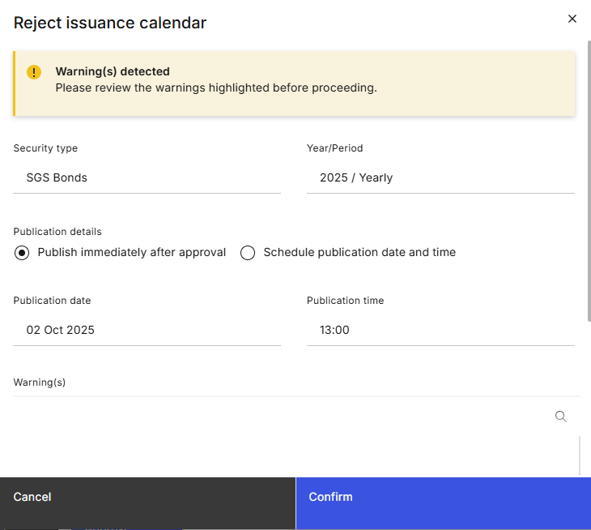

Figure 16: Confirmation Prompt

Confirmation Prompt
S/N | Name | Type  (Max Length) | Validation Rules | Remarks
1 | *Refer to remarks. | Modal Title |  | When the “Reject” button is clicked, “Reject issuance calendar” is displayed. If the “Approve” button is clicked, “Approve issuance calendar” is displayed.
2 | Warning banner | Warning Inline Notification without Close Button |  | The following is displayed if there is at least one warning.  “Warnings  Please review the warning(s) before proceeding.”
3 | Security Type | Label
4 | Year/Period | Label
5 | Warning(s) | Data Table |  | Displayed if there is at least one warning.  Displays the line number, the field name as well as the soft warning applicable for the field.
6 | Confirm | Primary button |  | Approves or rejects the issuance calendar based on the button the Checker clicks on the Issuance Calendar details page. Refer to 2.13.4 Post Conditions.
7 | Cancel | Secondary button |  | Closes the Confirmation Prompt.
Table 28: Confirmation Prompt Screen Elements

Export Issuance Calendar

Description
This use case enables users to export issuance calendars. This is mainly for Makers to send to SGX for ISINs.

Preconditions
- User logs in to the Intranet Portal.
- User accesses the Issuance Calendar Details page.
- An issuance calendar for the particular Security type, Year, and Period has been created.
- The issuance calendar has been saved as draft or submitted for approval at least once.

Business Requirements
- Role-based Access Control:
  - Issuance Calendar Viewer
  - Issuance Calendar Maker
  - Issuance Calendar Checker
- If there are multiple issuance types (e.g. for SGS Bonds), each issuance type is a separate tab in the file.
- Only exports the issuance calendar data that is stored in the database. If a Maker edits the issuance calendar and did not save it as a draft nor submit it for approval before exporting, the edits are not reflected in the downloaded file.
- When exporting issuance calendar, the “ISIN Code” and “CDP Naming Convention” columns are to be placed as the rightmost columns.
- Sort the results by ascending order of issue date and ascending order of tenor.

Post Conditions
- Download of the file is initiated.
- User remains in the Issuance Calendar Details page.

Issuance Calendar Details page
Refer to 2.7.6 for the screen elements in the Issuance Calendar Details page. For 2.14 Export Issuance Calendar, the page contains additional elements in the Action Button Row.

Wireframe
Refer to 2.7.6.1 Wireframe.

Action Button Row
S/N | Name | Type  (Max Length) | Validation Rules | Remarks
1 | Export calendar | Tertiary button |  | Refer to 2.14.4 Post Conditions.
Table 29: Action Button Row Screen Elements

Sample Files
For initial security types available in OMEGA, refer to the following files for a sample of the export:

Download Issuance Calendar Templates

Description
This use case enables users to download issuance calendar templates. This is for Makers to create the issuance calendars via file upload.

Preconditions
- User logs in to the Intranet Portal.
- User accesses the Issuance Calendar Listing Page.

Business Requirements
- Role-based Access Control:
  - Issuance Calendar Maker
- If there are multiple issuance types (e.g. for SGS Bonds), each issuance type is a separate tab in the file.
- The templates are based on the security type i.e. the template is the same for different subtypes and/or tenors. Refer to 2.15.6 Template Files for a list of templates available.
- When downloading issuance calendar templates, the “ISIN Code” and “CDP Naming Convention” columns are to be placed as the rightmost columns.
- Tenor (days) field for Bills is computed by OMEGA. Values in this column will be ignored by OMEGA when Makers upload the file.

Post Conditions
- Download of the template is initiated.
- User remains in the Issuance Calendar Listing page.

Issuance Calendar Listing page
Refer to 2.7.5 for the screen elements in the Issuance Calendar Listing page. For 2.15 Download Issuance Calendar Templates, the page contains additional elements in the Page Header.

Wireframe
Refer to 2.7.6.1 Wireframe.

Page Header Screen Elements
S/N | Name | Type  (Max Length) | Validation Rules | Remarks
1 | Download templates | Tertiary button with Dropdown |  | Open a menu list where templates used for file upload can be selected for download. Options available are:  - SGS Bonds  - MAS Bills  - T-Bills  - SSBs  - CMTBs  Additional options are available based on the name of the security type when new security types are created.  When the option is clicked, refer to 2.15.4 Post Conditions.
Table 30: Page Header Screen Elements

Template Files
For initial security types available in OMEGA, refer to the following files:
For created security types, the templates are as follows:
- Bonds (Bid collation happens over the month)
- Bonds (Bid collation happens over a specific number of days)
- Bills (Bid collation happens over the month)
- Bills (Bid collation happens over a specific number of days)

Logic for Creation of Issuance Calendars via Algorithm

Tenor in Days
The system shall apply a standardized day-count conversion for all tenors.
Tenor Unit | Tenor in Weeks | Tenor in Days
1-week | 1 | 7
3-month | 13 | 91
6-month | 26 | 182
9-month | 39 | 273
1-year | 52 | 364

T-Bills
- Get the applicable parameters for all tenors:
  - Issuance calendar’s Year and Period;
  - The primary issue/maturity day;
  - The number of business days before issue day (for announcement day); and
  - The number of business days before issue day (for auction day).
- For each tenor, get the applicable parameters:
  - The offset from the primary issue day;
  - The issue frequency in an interval; and
  - The prefixes for the issue code.
- For each tenor, repeat the following steps until the latest issue date falls outside of the issuance calendar’s Year and Period.

Issue date
  - Find the assumed primary issue date of the last issuance based on the primary issue/maturity day.
  - Derive the assumed primary issue date based on the assumed primary issue date of the last issuance and the issue frequency in an interval.
    - Assumed primary issue date of the subsequent issuance = assumed primary issue date of the last issuance + issue frequency in an interval.
  - Derive the actual primary issue date.
    - If the assumed primary issue date falls on a public holiday, actual primary issue date = assumed primary issue date + 1 business day.
    - Else, actual primary issue date = assumed primary issue date.
  - Derive the issue date based on the actual primary issue date.
    - Issue date = actual primary issue date - offset from the primary issue date (in business day(s)).

Announcement and auction date
  - Derive the announcement date and auction date based on the actual primary issue date (from 3c).
    - Announcement date = actual primary issue date - the number of business days before issue date (for announcement date).
    - Auction date = actual primary issue date - the number of business days before issue date (for auction date).

Maturity date
  - Derive the assumed primary maturity date based on the assumed primary issue date (from 3b) and the tenor.
    - Assumed primary maturity date = assumed primary issue date + Tenor in days.
  - Derive the maturity date based on the assumed primary maturity date.
    - Maturity date = assumed primary maturity date - offset from the primary issue date (in calendar day(s)).

- Filter the results based on the year and the period of the issuance calendar to be created against the issue dates. Sort the results by ascending order of issue date and ascending order of tenor.
- For these results, generate the issue code based on the prefix for the issue code.

SSBs
- Get the applicable parameters:
  - Issuance calendar’s Year and Period;
  - the primary issue/maturity day of the month;
  - the announcement day;

  - the number of business days before issue date (for allotment date);
  - the issue frequency in an interval; and

  - the prefixes for the issue code.
- Repeat the following steps until the latest issue date falls outside of the issuance calendar’s Year and Period:
  - Find the issue date of the subsequent issuance based on the last issuance, the issue frequency in an interval, and the issue day of the month.
    - Month and Year of issue date = From the Month and Year of the last issuance’s issue date, add the number of months based on the issue frequency.
    - Day of issue date = primary issue/maturity day of the month.
    - If the issue date falls on a weekend or public holiday, the issue date is shifted to the next business day.
  - Derive the announcement date based on the issue date.
    - Month and Year of announcement date = Month and Year of issue date - 1 month.
    - Day of announcement date = the announcement day (parameter).
    - If the announcement date falls on a weekend or public holiday, the announcement date is shifted to the next business day.
  - Derive the allotment date and closing date based on the issue date.

    - Allotment date = issue date - the number of business days before issue date (for allotment date).

    - Closing date = Hardcoded to be 1 business day before allotment date.
  - Derive the maturity date based on the issue date.
    - Month and Year of maturity date = Month and Year of issue date + tenor.
    - Day of maturity date = the 1st calendar day of the month.
    - This maturity date does not change even if it falls on a public holiday.

- Filter the results based on the year and the period of the issuance calendar to be created against the issue dates. Sort the results by ascending order of issue date and ascending order of tenor.
- For these results, generate the issue code based on the prefix for the issue code.

MAS Bills

- Get the applicable parameters for all tenors:
- Issuance calendar’s Year and Period;
- The primary issue/maturity day;
- The number of business days before issue date (for announcement date); and

- The number of business days before issue date (for auction date).
- For each tenor, get the applicable parameters:
  - Tenor value and unit;
  - The offset from the primary issue date;
  - The issue frequency in an interval; and
  - The prefixes for the issue code.
- For each tenor, repeat the following steps until the latest issue date falls outside of the issuance calendar’s Year and Period.

Issue date
  - Find the assumed primary issue date of the last issuance based on the primary issue/maturity day.
  - Derive the assumed primary issue date based on the assumed primary issue date of the last issuance and the issue frequency in an interval.
    - Assumed primary issue date of the subsequent issuance = assumed primary issue date of the last issuance + issue frequency in an interval.
  - Derive the actual primary issue date.
    - If a public holiday falls between Monday to the assumed primary issue day of the week (inclusive), actual primary issue date = assumed primary issue date + 1 business day.
    - Else, actual primary issue date = assumed primary issue date.
  - Derive the issue date based on the actual primary issue date.
    - Issue date = actual primary issue date - offset from the primary issue date (in business day(s)).

Announcement and auction date
  - Derive the announcement date and auction date based on the actual primary issue date (from 3c).
    - Announcement date = actual primary issue date - the number of business days before issue date (for announcement date).
    - Auction date = actual primary issue date - the number of business days before issue date (for auction date).

Maturity date
  - Derive the assumed primary maturity date based on the assumed primary issue date (from 3b) and the tenor.
    - Assumed primary maturity date = assumed primary issue date + Tenor in days.
  - Derive the actual primary maturity date.
    - If a public holiday falls between Monday to the assumed primary maturity day of the week (inclusive), actual primary maturity date = assumed primary maturity date + 1 business day.
    - Else, actual primary maturity date = assumed primary maturity date.
  - Derive the maturity date based on the actual primary maturity date.
    - Maturity date = actual primary maturity date - offset from the primary issue date (in business day(s)).

- Filter the results based on the year and the period of the issuance calendar to be created against the issue dates. Sort the results by ascending order of issue date and ascending order of tenor.
- For these results, generate the issue code based on the prefix for the issue code.
- Soft validations:
  - Issue date does not fall on a past maturity date of the same tenor

The assumed primary issue/maturity date is the date for the primary issue/maturity day for that week (regardless of public holidays). For example, if the primary issue/maturity day is Friday, this would be the date for all Fridays.
The actual primary issue/maturity date is the assumed primary issue/maturity date, after adjusting for public holidays.
The assumed primary issue/maturity date is the date for the primary issue/maturity day for that week (regardless of public holidays). For example, if the primary issue/maturity day is Friday, this would be the date for all Fridays.
The actual primary issue/maturity date is the assumed primary issue/maturity date, after adjusting for public holidays.

